

Rome

25 March – 29 March 2019

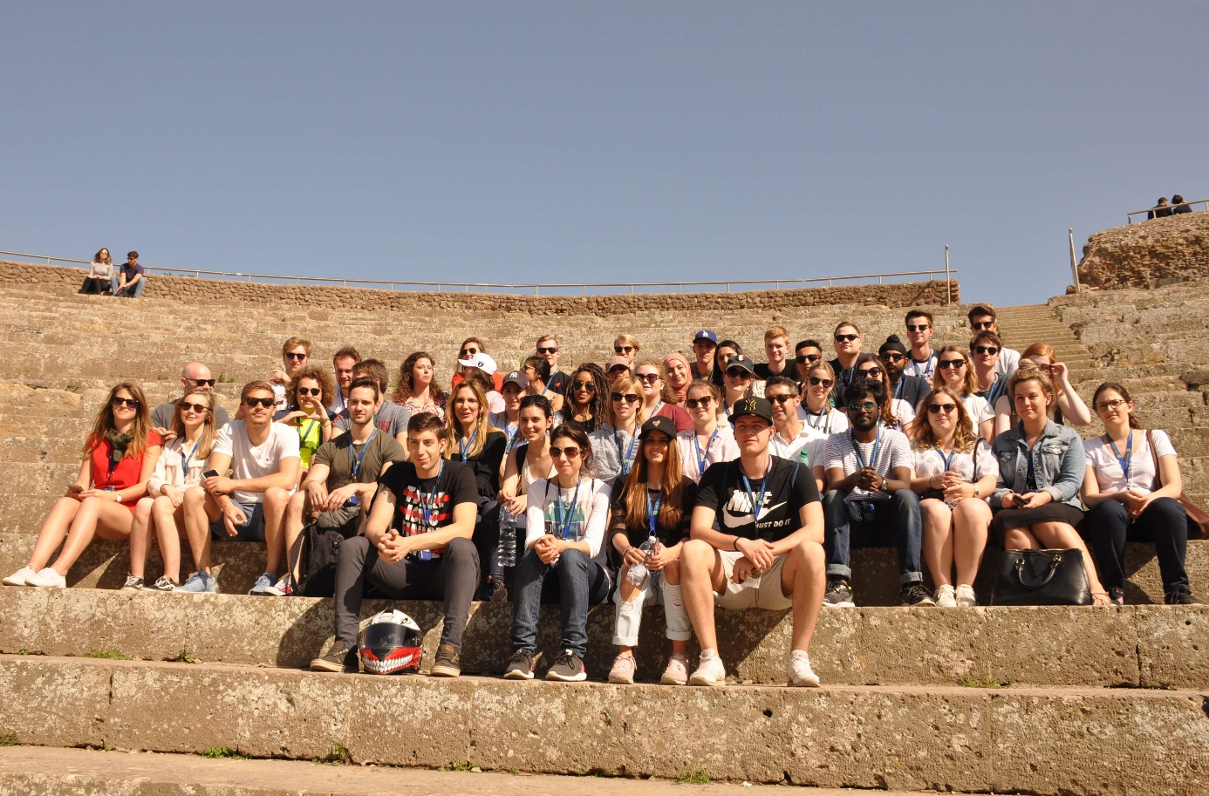

International ENTREPRENEURIAL Week Rome

Swiss School of Management

Project concerning Entrepreneurship

A challenge for inventive students

Outline of the programme

The main target of this week is to let students work in mixed international groups on a subject that interests them, which makes them think and communicate in another language. In this way our target group, second year students with as main subject Business Management (entrepreneurial background) broaden their practical knowledge of their field of expertise: various aspects of entrepreneurship, languages and culture.   
  
The students will visit a company that challenges the students with an assignment they will have to carry out that week. The challenge will focus on different aspects of a company. Guest lectures will provide the students with additional information that is linked to the challenge and will help them to carry out the assignments.

We form groups of people with different nationalities. The more nationalities involved, the more interesting it is for the students.  
  
At the end of the week, the groups present their results.

Communication Business Week

A private platform will be used to share documents that will be used during the business week. More information about the communication channel will be given in due time.

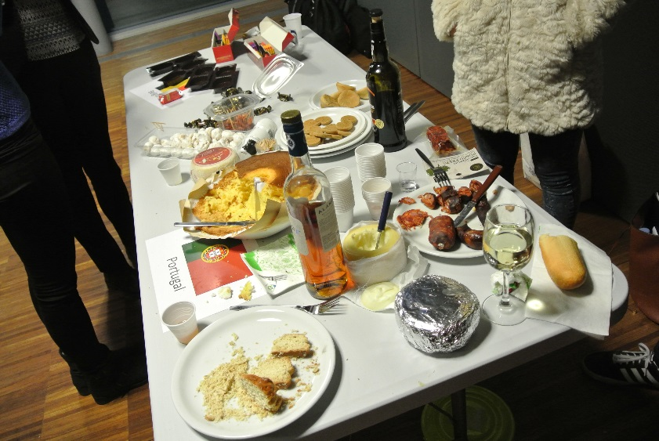



Presentation partner institutions

Everyone is curious to know more about the country the others come from. Students from every institution have to prepare a presentation about their country, their school, ... .

International reception

One of the objectives of the International Entrepreneurial Week is to familiarise with the cultures of the different participants.

Company visit

We will visit the company that will provide a challenge for the students.

Accommodation

You’ll be staying at World Hotel Ripa Rome in the local Trastevere neighbourhood from Monday, March 25 until Friday, March 29, 2019.



**Programme International Entrepreneurial Week Rome – March 2019**



**Tuesday 26 March**

Company Visit

Working session –

Part 1

**Monday 25 March**

Official Welcome

Presentations international partners and international reception

Guest Lecture

Hidden Rome Tour

**Thursday 28 March**

Preparation pitches

Pitching results

Official dinner

**Wednesday 27 March**

Cultural activity

Guest Lecture

Working sessions – Part 2

**Friday 29 March**

Feedback session