International Business Week Rome

(23 April – 27 April 2018)

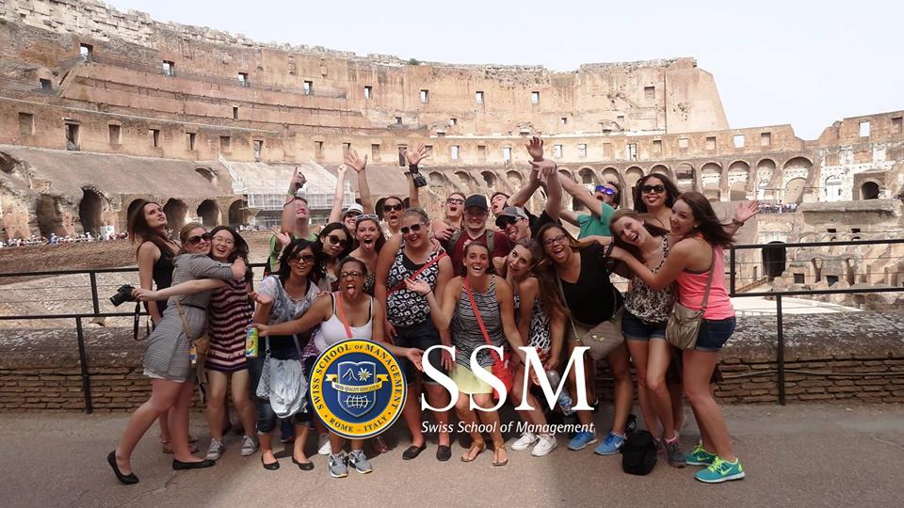



1st Business Week Rome (23 April – 27 April 2018)
List with lecturers and students from UC Leuven-Limburg

Please, mail this form to Massimo Bracalé (massimo.bracale@ssmrome.com) by latest December 15th, 2017.
Subscription fee

Participation Business Week: 13 students x €450 = 5850 €
Fee includes: 4 nights, breakfast, transport in Rome, Cultural Activities, closing down dinner on Thursday.

After registration you will receive an invoice with the necessary information for the payment. Please fill in your complete details so our finance department can prepare the invoices correctly. The registration is final after payment of the invoice.

Your references
Official name of the school/university: ……………………………………………………………….
Person to address invoice to: …………………………………………………………………………
Address:

VAT number: …………………………………………………………………………………………
Lecturer(s)
Name and first name | E-mail | Gender | Date of Birth | Place of Birth | Nationality

Students
Name and first name | E-mail | Gender | Date of Birth | Place of Birth | Nationality

Provisional Programme Business Week Rome April 2018

 | Business Week Rome April 2018
Monday April 23rd | 3 pm Arrival Official welcome at SSMROME
Monday April 23rd | 4 pm Introduction Session Business game + round 1
Monday April 23rd | 6.30 pm Short presentations by guest students (partner institutions) & Reception international products
Monday April 23rd | 8 pm Cultural activity
Tuesday April 24th | 9 am Guest lecture on cross cultural communication and cultural differences by Eline Delauré (UCLL)
Tuesday April 24th | 10 am Business game 2nd round
Tuesday April 24th | 12 am Lunch outside
Tuesday April 24th | 2 pm Cultural activity
Wednesday April 25th | 9 am Business game 3rd round
Wednesday April 25th | 11.30 am Workshop Pitching by Eline Delauré (UCLL)
Wednesday April 25th | 1 pm Lunch outside
Wednesday April 25th | 3 pm Cultural activity
Thursday April 26th | 3 pm preparation presentation (pitching)
Thursday April 26th | 4 pm Final presentations with jury (pitching + questions)
Thursday April 26th | 8 pm Official dinner and closure of the week

