EntreMWB – Entrepreneurship Mental Well Being Project
A European Erasmus+ project
(In which Businet is a partner)

The Entre-MWB project which begin on January 21 sought to support young entrepreneurs across Europe and to ensure the effectiveness and efficiency of European start-ups by developing supportive educational materials that encourage reflection, understanding, diagnosis and ensure mental resilience and are directly supportive of their health and wellbeing.
The project proposal was developed during the working group sessions of the Annual Businet Conference in Belgrade in November 2019. The project spans two working groups, and Social Matters and Entrepreneurship with members of both groups collaborating on the on the project.
Recent research and publications have publicised the relationship between entrepreneurship and mental illness in a range of forms. This was brought to international attention by a range of presentations to the World Economic Forum (WEF) in Davos in 2019. Entrepreneurs provide economic benefit to any society in which they operate yet little consideration has been given to their mental well-being (MWB) in an increasingly challenging business environment.
The partnership was made up of three universities, two SMEs, two associations and two social enterprises, their focus of innovation is to provide unique self-help and self supportive training materials that will support young entrepreneurs in understanding the qualitative dimension of entrepreneurship; prepare young start-ups for the challenges and demands of entrepreneurship in advance and provide a resource that can add value to an existing vocational programme of business and/ or enterprise studies and add value to the business start-up support that is currently provided.
The project was completed in June 2023 and the final training materials are now freely available to start-up and would-be entrepreneurs, business and enterprise undergraduates and alumni. The are also available to partners and associated partners that provide business support to start-up companies through the project website at https://entremwb.eu
The five measurable objectives of the project were:
- To engage with entrepreneurs to identify the key areas where support is needed for the maintenance of mental health and work-life balance.
- To identify European good practice and implement best and proactive practices of mental health support supported by published case study materials for disseminate to a range of target groups.

- Assess effective approaches to ensure health and well being that are practised in Europe and publish such findings throughout Europe.

- Deliver training and awareness programmes covering all aspects of mental health and well-being to support new entrepreneurs.

- Publish case study materials, teaching cases, training materials, fact sheets that support the mental health and well being of entrepreneurs to ensure 24/7 access.

Project Partners:
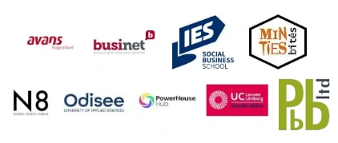
Want to learn more?

Visit the project website at https://entremwb.eu

