ENTER-CBL: Boosting Entrepreneurial Mindset of Students with Challenge-Based Learning
Businet is a partner in the successful application for KA220-HED - Cooperation partnerships in higher education, which will begin on 1st November 23. The project will be co-ordinated by Businet member WSB, Poland.
The overall aim of ENTER-CBL project is, on the one hand, to create entrepreneurship course to students from four different European universities, developed based on an innovative CBL Methodology for Entrepreneurship Education, and on the other hand, to develop and to provide training, materials, and best practices in relation to CBL framework.
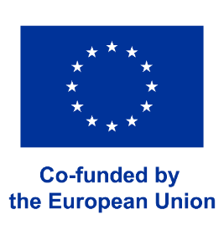
Project partners:
- Businet
- WSB University
- Romanian-American University
- Istanbul Aydin University
- Polytechnic Institute of Porto

