Dale Lyon - Director of ExpLearn Limited
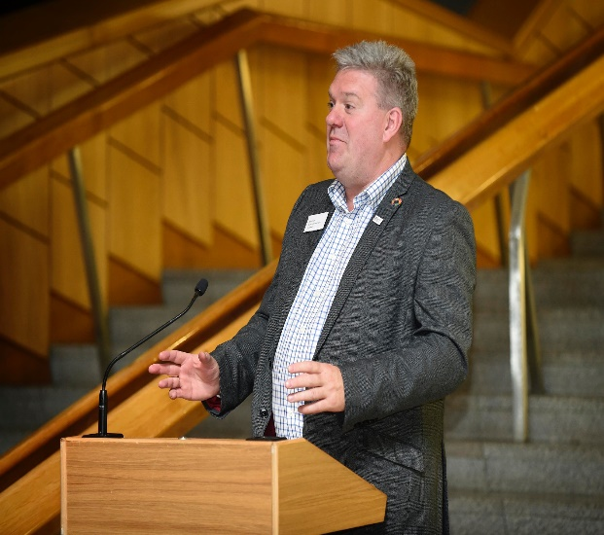
Developing and delivering experiential learning activities globally.

Having first been introduced to BUSINET as a collaborating partner in the Erasmus + PEETS (Promoting Excellence in Employability and Transversal Skills) project when David Taylor visited our purpose built training facility in West Lothian, Scotland to see the activities that we were developing at ConStructEd Scotland.
After attending my first Conference at Villanoura ii quickly immersed myself in BUSINET Working group activities having supported students through their Trade Mission journeys and Busidays activities before actively helping develop the current format of the successful Student Conference and more recently instigated the formation of the STEM working group to further expand the outreach to the science, technology, engineering, technical and mathematics faculties.
I now feel that the time is right to become more involved in the management of the organisation having the time to devote to such an undertaking and to further help in the future development of such a unique organisation as BUSINET.

