Dinand Warringa
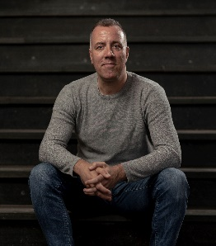
My name is Dinand Warringa (49) and I have been working in education for nearly half of my life, as a teacher of Business English and diplomatic skills. I was actually trained as an interpreter and translator in English and German at HUB university (Brussels, Belgium) but the prospect of having to translate manuals and EU legislative documents just didn’t have the same appeal as teaching, as you can probably all relate to.
As course coordinator of our International Relations programme and as Global Programmes Coordinator within Windesheim UAS (NL), I am dealing with virtual internationalisation initiatives such as COIL, BIP and other virtual exchange projects. Since 2018 I have been representing our university at Businet and I feel privileged to be part of our thriving international community.
The phrase ‘Put your money where your mouth is’ is the main reason for me to apply for the post of Businet’s Board member. I feel that I can truly contribute to Businet’s plans and challenges by being actively involved. The first time I experienced the buzz and energy of all of us was when I attended the Belgrade conference – I felt encouraged by the energy of like-minded professionals and our common goal to share best practices and to excel in intercultural and cross-institutional teaching.
As Board member I intend to continue the work of the current board yet add my experience in multicultural lecturing, virtual and online teaching and international cooperation practices, such as a number of international bilateral projects that I am currently coordinating.
Of course, covid-19 meant a (temporary) halt to many wonderful teaching and research practices and I do not want to underestimate the blow to some ambitions and plans we initially had. I do feel, though, that internationalisation is much more than merely exchanging students and staff – it really is a mindset of being an international diplomat, of opening up to others, regardless of physical boundaries or preconceptions. As Board member I hope to contribute to expand more and more facets of internationalisation, from boosting even more cross-university teaching programmes to installing a genuine international mindset among our students – and of course working closely together with my fellow board members.
Please feel free to contact me if you have any questions or comments: d.warringa@windesheim.nl.
All the best!
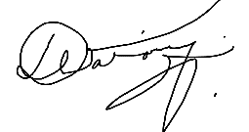 Dinand

