Exploring the Wider City of Tallinn
This tour will take you out of the centre of Tallinn and explore some of the sites surrounding the medieval city.
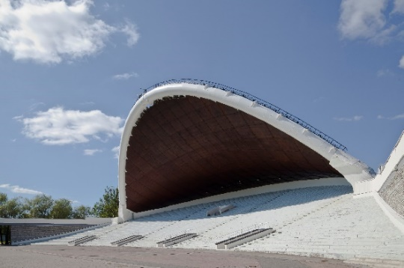
09.00 Departure with guides from the Hilton Tallinn Park
The tour begins with a drive through the seaside district of Pirita, passing the renowned TV Tower before stopping at the Song Festival Ground. The Song Festival Ground was built in the 1960’s for the famous Song Festivals of Estonia, that became symbolic during the Soviet period. They became a symbol of dignity, freedom and the reborn Estonia.
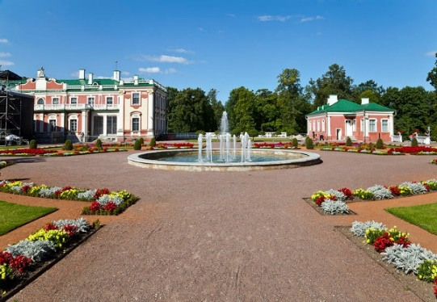
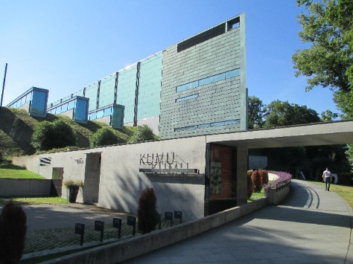
We will then drive to Kadriorg Palace which is considered to be the grandest example of palace and park design in Estonian. A short walk from Kadriorg Palace will take us to KUMU. Kumu is the headquarters of the Art Museum of Estonia, as well as the largest and most impressive exhibition venue in Estonia. The museum opened on 17 February 2006. In 2008 Kumu received the European Museum of the Year Award. This is a noteworthy international recognition of Kumu’s aspiration to become a truly contemporary art museum, which is not just dedicated to collection, conservation and exposition, but is a multifunctional space for active mental activity, from educational programmes for small children to discussions about the nature and meaning of art in the modern world

13:00- 14:30 2 Course Lunch in restaurant Olde Hansa in the heart of Tallinn
After lunch there is a choice of two tours - you must choose which tour you wish to take in advance.
Afternoon optional Tours:
Option 1: 14:45- 15:45 Visit the KGB Museum
This museum tells the story of life during the KGB era. It is a treasure trove of stories depicting two different worlds. An idealistic world, which existed mainly on paper, of happy Soviet citizens living in friendship and never wanting for anything, led by a wise, all-powerful group of men in a place where there were no accidents or catastrophes. The other, the real world, which was a very different and much tougher place to live!

Option 2: 15.00 - 16.30 Visit to the Seaplane Harbour Museum
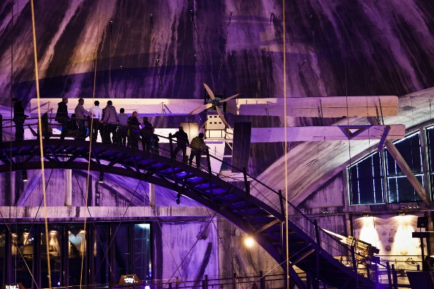
The Seaplane Harbour opened in 2012 and is a very unique and interactive attraction. The seaplane hangars and the complex that forms the Seaplane Harbour, were initially completed as part of Peter the Great's Naval Fortress in 1916-1917. Seaplane Harbour in Tallinn is one of the most unique maritime museums in Europe, with a display comprising of over two hundred large exhibits. Legends here come to life - the submarine Lembit, the Suur Tõll steam icebreaker (Toell the Great, in English) the Short Type e 184 seaplane, and other life-sized exhibits are waiting for you.
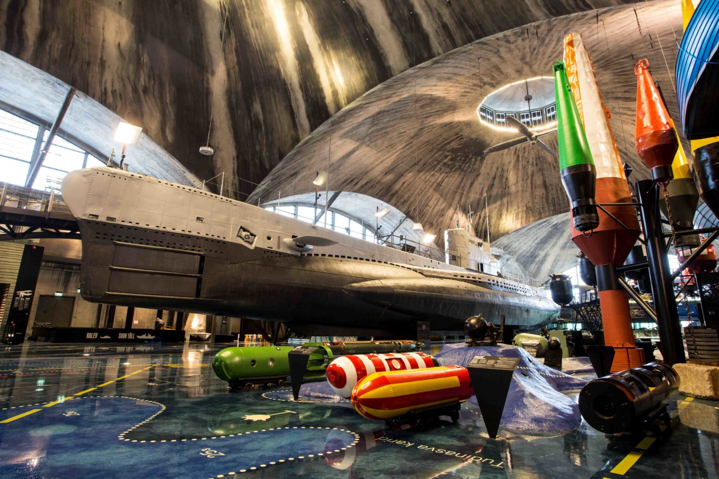
The KGB Tour ends at 15.45 and the Sea Plane Harbour excursion should have you back at the hotel at 17.00

