Saturday Social Tour

The Eastern Algarve: Castro Marim, Tavira, and Faro 11th November 2017

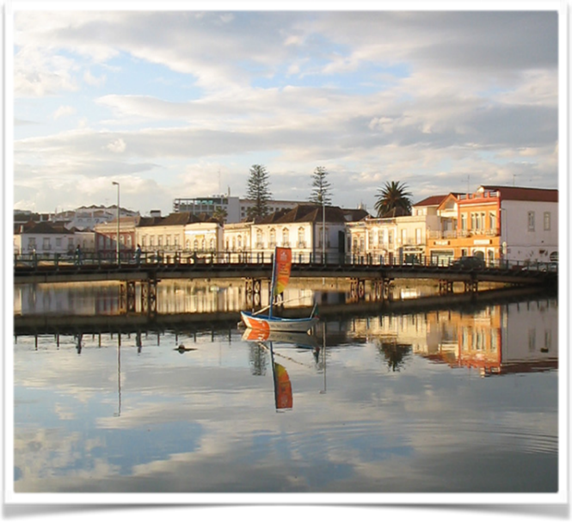
08:30 Departure with guides from the Hilton Hotel
travelling to Castro Marim castle.

Learn about the village, traditional activities
and the role that the area played in the re-
conquest and defense of the territory.
Visit to the old castle dating back to the
VIIIth Century and classified as a
National Monument since 1920.

10:30 Departure from Castro Marim on
the 125 National road to Tavira.

11:15 Arrival in Tavira. Panoramic view before stopping in Tavira.

Dating back to the Bronze Age and with numerous reminders of its Roman past and the Moorish occupation, Tavira is one of the most typical cities of the whole
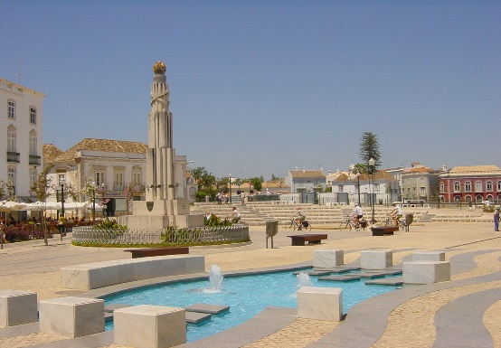
Algarve. The town lies where the River Gilão meets the Atlantic Ocean. Apart from Tourism the main industries of the town are linked to the sea. Fishing and the extraction of salt being key to the local economy.

Famous for its narrow streets and monuments, Tavira has more than 30 Churches and Chapels. The Town has a maze of small roads and passageways, designed many originally designed for defensive purposes

13:00 Lunch break near Faro - Chicken Piri-Piri

Lunch at a typical chicken Piri-Piri restaurant, which is a traditional Algarvian dish.

Afternoon in Faro

14:40 Arrival to Faro.
After lunch guests have 3 options for which they choose on arrival at the conference (or prior to the conference):

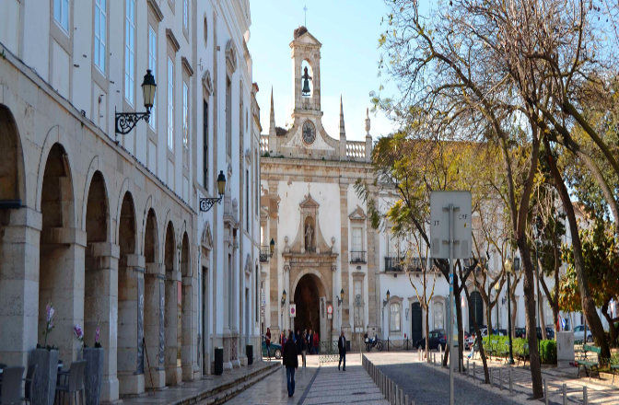
- Faro is a lovely pedestrian friendly small town,
and guests are invited on a guided walking
tour through the old part of the town,
surrounded by the medieval walls.

2) Time to enjoy lovely views of the Ria Formosa
Natural Park, one of the most amazing places of
the Algarve, not only for its variety of landscapes
but also because of its unique location.
On a small ferry boat, guests will have a 1,5 h
tour accompanied by a biologist guide.
Numbers are limited however and registration will be taken of a first served basis.

3) In Faro, you can take free time to visit the town. There is traditional shopping in
cobbled streets where local shops offer a good selection of local products. Or
enjoy a coffee and Pastel de Nata in one of the numerous cafes.

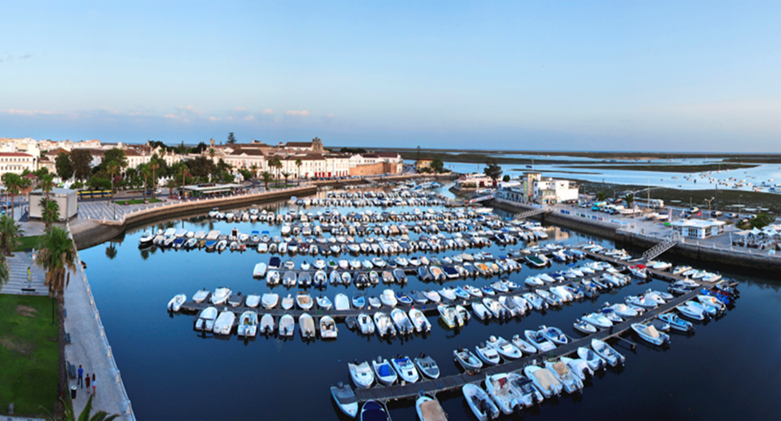
17:00 Departure from Faro

17:30 Arrival at the Hotel

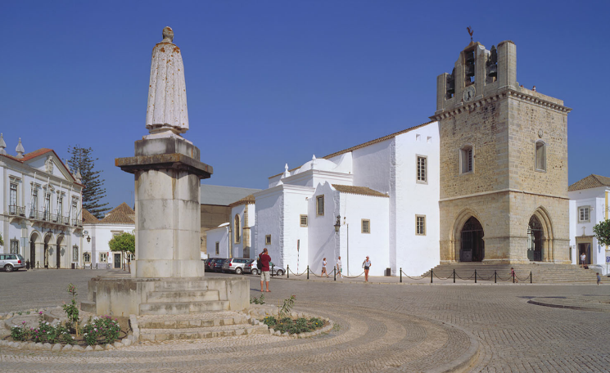

Enjoy the Trip!

