24 hours to solve the waste problem

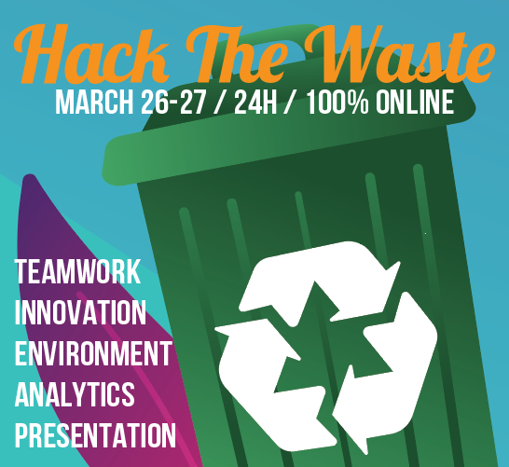

8 international teams of students try to solve a waste problem in 24 hours.

26 – 27 March 2021, Belgium, Brazil, Denmark, Latvia, South Africa, The Netherlands

“We have to shock people. Maybe then they will realise the effects of waste.” Eline Schepers and her five companions of Hack4Change suggested setting up an educational game to improve waste selection among Renewi’s clients; Renewi being a major European waste handler. Their proposal won the Hackaton 2021: a contest among students of 6 universities.
Starting on Friday 26th March 2021, the 8 teams of 8 students each got 24 hours to develop a project to tackle a waste problem of a company in the circular economy.
Ronahi Nur Ustboga of team Hack4Change: “Our online advert links to a kind of educational test, a platform which offers SME-clients of Renewi the challenge to think and act like a recycler: to sort properly so that the waste can be recycled and not incinerated.”
“Realizing a business plan in 24 hours is hard work,” confesses Laura Kaupere from The School of business and finance in Latvia. “After Renewi’s briefing at noon and a short lecture on brainstorms we started off. We got plenty of ideas but at 3 o’clock we had to pitch only three. A jury selected the best idea. A couple of hours later we had to pitch our plan and were advised by the jury.”
Laura: “Employers of the SME-clients can play the game. In the end, the client can earn a badge, indicating the company is respectful of the environment. Renewi’s clients can see which other companies have a badge, and hopefully will be triggered to also obtain a badge.”
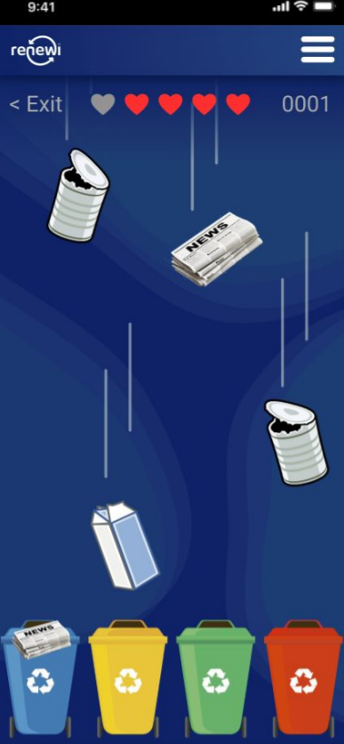
Miroslav Hradsky from UCN, Denmark: “I made a prototype of the visuals that we needed for the game. Others took care of the financial plan and the risk assessment. We also had to develop a marketing plan and work on our public relations.”
“We are a transdisciplinary team,” says Mylène Hermse from Avans, The Netherlands. “I study business innovation, Elien Information Technology and Miroslav Multimedia Design. Ronahi wants to become a law practitioner and Laura a business process manager. Although we all have a particular background, we hardly notice the differences.”
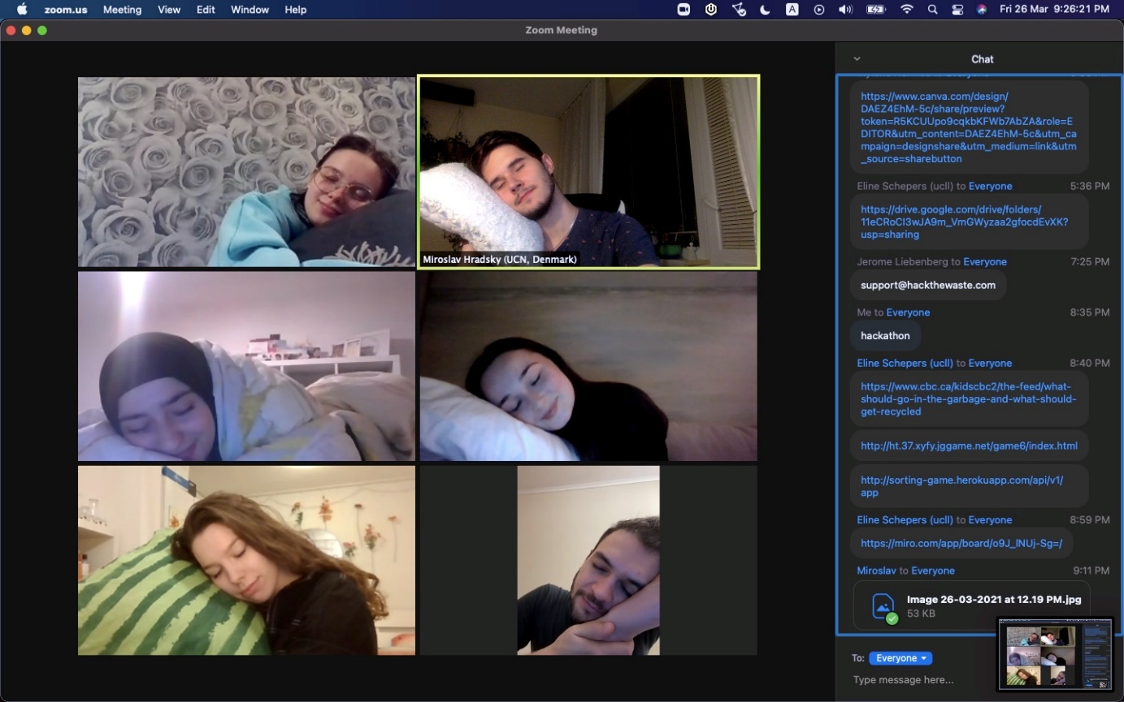
Eline Schepers from UCLL, Belgium: “I’m proud that I made it: we only had a very short nap. It is a strange experience: we remained together online and continued work the whole night through. But talking and understanding different kinds of English is exhausting!”
Ronahi Nur Ustboga from UCLL, Belgium, “I enjoyed the Hackaton: working together was a fine experience. Far better than the groupwork we usually have to do! Everybody tried their best. And that’s why we won!”
Renewi offered the winning team a tree. Eline “We still have to decide where we want our tree to be planted. Maybe somewhere in Africa!”

8 great ideas
Renewi, a Dutch-British multinational which handles 14 million tons of waste each year, envisages becoming a leading waste-to-product company in the circular economy. Yob Woud of Renewi presented the case to the students. “We notice that within the bins of small enterprises, there’s a lot of paper packaging and plastic foils. Unfortunately this waste will most likely be incinerated. Separating this mixed and dirty stream afterwards is not possible: it takes too much energy and is too costly. So Renewi wants to enthuse our SME clients to separate their waste, increase recyclable monostreams and reduce residual waste.”
The winning team proposed an educational game. Other teams advised Renewi to investigate in a waste tracking system involving QR-codes, a kind of dishwasher for waste, a waste sorting app combined with weight sensors in bins, a Green Card (a kind of sustainability logo) etc.
The jury awarded the price to Hack4Change. David Taylor, member of the jury and Chairman of Businet: “It was a clear and coherent idea. We were very pleased with the presentation in which all members took part.”
Hack The Waste offers students from the Netherlands, Belgium, Denmark, Latvia, South-Africa, Croatia, Slovenia and Serbia the opportunity to provide new perspectives in the development of concepts, design, marketing and business strategies. The Hackaton is an annual event which normally takes place on the campuses: students camp for 24 hours and use social media for cross-border co-operation. Due to Covid-19 students had to work from home in the 2020 and 2021 edition.

www.hackthewaste.com
www.renewi.com

