Introducing the organisation

Businet was established in 1987 and is a strong Network of Institutes of Higher Education. It is represented in 27 countries. The initial aims of the organisation were to enable the establishment of European programmes in business to promote opportunities for Institutions of Higher Education, their staff and their students.

As the needs of our member organisations have changed, and as the membership profile has altered, reflecting the growth and diversity of education globally, then so have the activities of Businet. The organisation however still keeps at its heart the needs of its member Institutions.

The network is a very practical one. Businet endeavours to make the difficult task of providing worldwide
opportunities for institutions and students easier for all.
What sorts of activities are undertaken across the Network?

Member organisations work together on activities such as:

- Annual Conference
- Student exchange
- Staff exchange
- Joint curriculum development projects
- International work placements
- Leonardo da Vinci projects such as thematic networks
- Intensive programmes
- Student conferences
- Curriculum specific working groups
- Special projects e.g. an international trade mission, an international MOOT court.

The network is an active one, offering differing opportunities to meet the various needs of the different member institutes.

Annual Conference

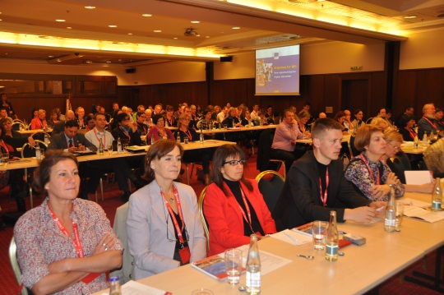
The Annual Businet Conference is where many of the network activities take place and projects are conceived. The conference is held in November and is central to the planning processes of many of the member institutions. Recent conferences have been held in Cannes, Estoril, Sinaia, Athlone, Berlin, Riga, Palma, Durham, Florence, Istanbul, Bratislava, Malta and Zagreb. The 2016 conference will be held in Budapest in November. It would indeed be a great pleasure to welcome you there.

Student Exchange

Student mobility between member institutions is a common practice. The relationship between members ensures that mobility activities are enhanced. Businet assists in providing a framework for co-operation and relationships between partner institutions.

Staff Exchange

The networking opportunities offered by the organisation are ideal when looking for and setting up staff mobility assignments. Having an on-going relationship with other organisations in the network facilitates this type of activity.

International Work Placements

Most member institutions make applications for the mobility of students on Erasmus or Leonardo funded placements. They often use fellow member institutions as placement "finders/identifiers" outside of their home country - sharing information to help each other. Businet also offers certification of the placement period with the "Certificate of International Business Practice".

Intensive Programmes
A number of member organisations organise intensive programmes together with fellow Businet members. Thus providing added value to the programmes of study on offer in their organisation and consequently giving them a competitive advantage.

Student Conferences

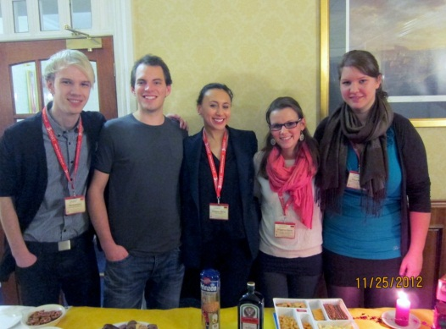
A student conference has been held every year since 1999. The aim of this conference is to bring students from a number of countries together to undertake activities surrounding a theme. Conference themes have incorporated cross cultural communication, preparation strategies for work experience outside of the home country and employability skills. The Next conference will be held in Edinburgh at the end of November. This conference is called the Unite conference. Details of last year’s event can be found on the Businet website www.businet.org.uk.

Curriculum Specific Working Groups

There are a wide range of curriculum groups working within the Businet network. The groups reflect the needs of the curricular needs of the member institutions. The groups include for example ICT, Marketing and International Trade, Tourism, Administrative Management, Law, Finance, and Communications. Three other cross-curricular groups were established in addition to meet the needs of groups from within the member institutions, that is International Relations Managers, Decision Makers Forum and Lifelong Learning.

I would be very pleased to expand the information provided above for any specific issue if you wish. The beauty of the network, in my opinion, is that works at whatever level of activity the member institution wants to work at. So you can get involved in lots of activities, or simply use the network as a vehicle to further your institutional aims.

